SHARP SHOOTER FINISHED GOODS RETURNS STEPS

Step 1. Create Negative Release

The Following provides a bill of lading for your truck to pick up the Returned Goods.
From Order Entry, click the Release Folder and add a negative quantity release for the amount of finished goods being returned. The customer service representative processes a release just as a normal order except the quantity is negative. They can also simply click the BOL button directly from the order line item screen and bypass creating a release. The advantage of this process is the truck driver has a formal bill of lading document for picking up the returns goods. For example, we ship 10 units at 1000 per pallet with tag numbered 1 to 10. Two units are returned by creating a negative release for 2000, which creates a bill of lading for negative 2 units at 1000 per unit with NO TAG Number. This in turn creates a negative invoice, thus updating the inventory with 2000 on hand without a blank tag number.

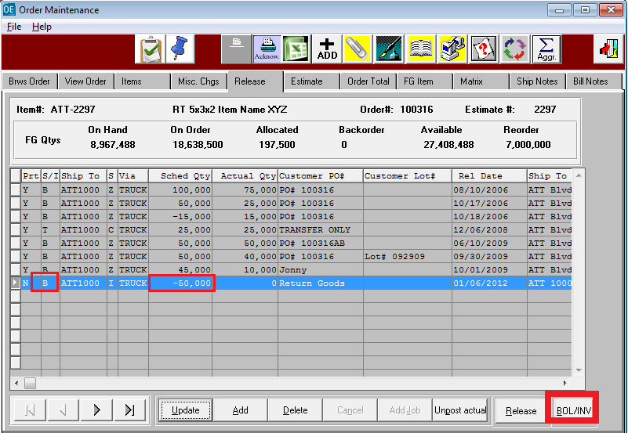

Step 2 Print and Post Bill of Lading

Print the Bill of Lading and Post the Bill of lading. Inventory is adjusted depending on N-K-1 BOLPOST logical Value. When logical value = YES, posting the bill of lading for the negative release, the system posts a negative shipment which creates a positive finished goods balance with a blank load tag number, which is used for Sharp Shooter returns. When N-K-1 BolPost logical value = NO, posting the bill of lading for the negative release, the system posts a negative shipment which creates a positive finished goods receipts with a blank load tag number and also and ALSO a negative receipt, which effectively has no effect on inventory. This option is best used to simply add Cycle Counts for returned Tags

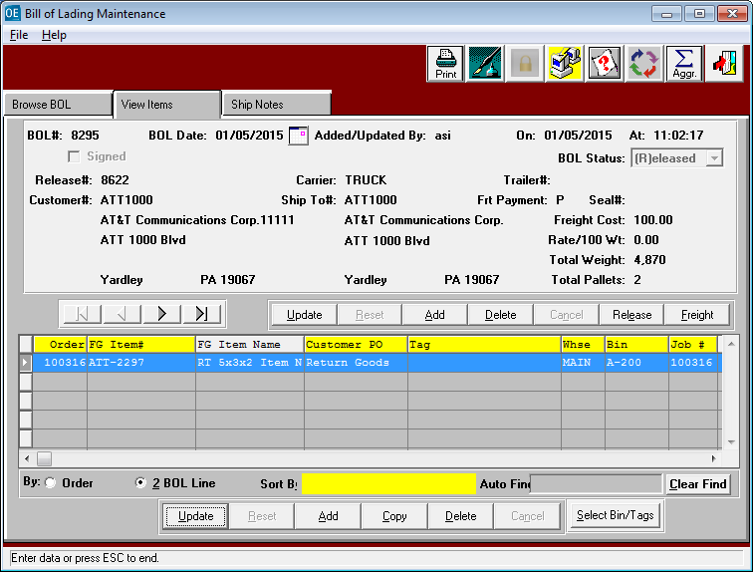

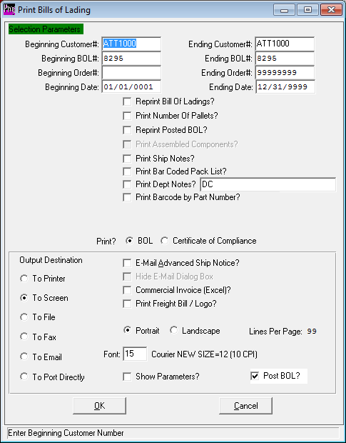
Step 3 Print and Post Invoice

The invoice is for a negative quantity times the sells price which is equivalent to a credit memo.

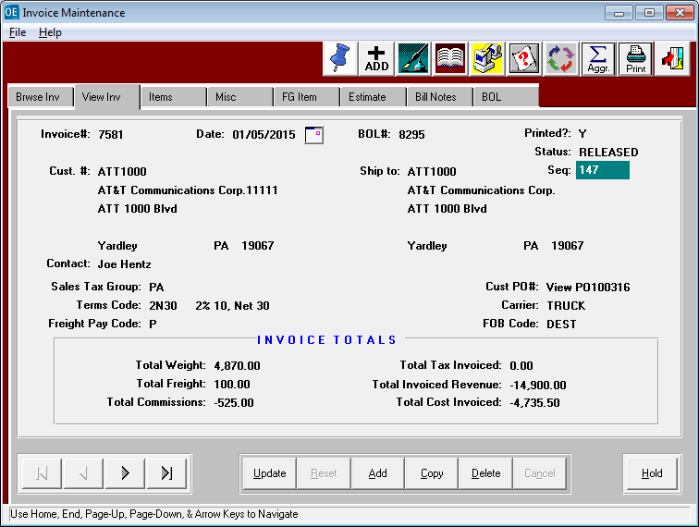

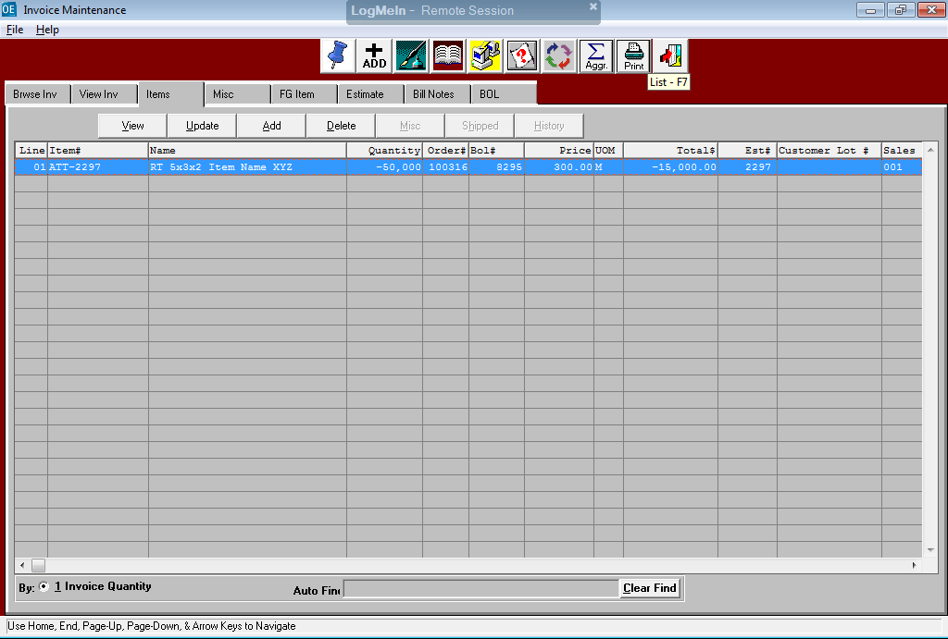

Step 4 N-K-1 BOLPOST LOGICAL VALUE INVENTORY CONTROL

Bill of Lading Shipments will subtract from inventory so a negative shipment will increase inventory. N-K-1 BOLPOST Logical Value = NO will create both a Negative receipt and Negative Shipment which will equal ZERO On Hand. Whereas, N-K-1 BOLPOST Logical Value = YES will only create a Negative Shipment which will increase the blank tags On Hand Quantity.

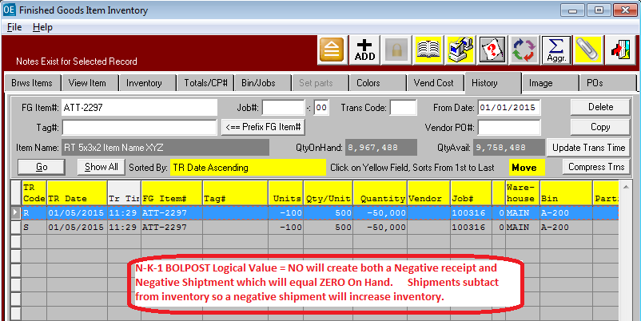

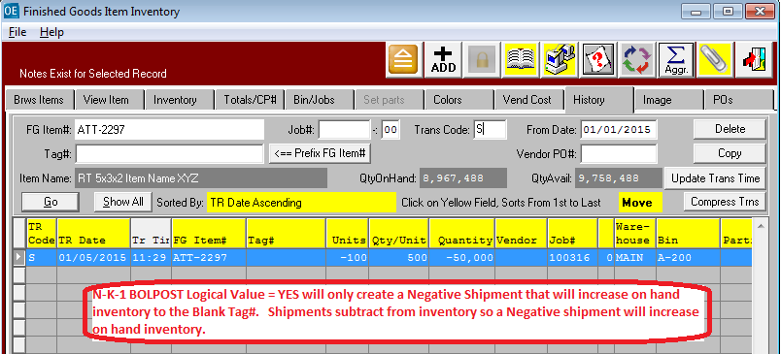

Step 5 CYCLE COUNT FOR RETURNS WITH PALLET TAGS

This option is used when N-K-1 BolPost Logical Value = NO, which creates a zero balance for the negative release. This option creates a negative receipt for a blank tag that offsets the negative shipment which increase inventory for the blank tag. This assumes that the returned goods still have the original pallet tags on each pallet that is returned. Therefore, this is the same logic as any other cycle count. For each pallet tag that is returned, the tag will cycle counted for the new quantity that will be returned to invemtory.

v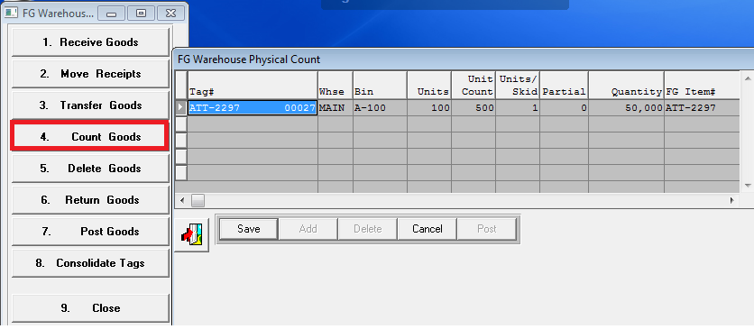

Step 6 LOADTAG CREATION FOR RETURNS WITHOUT TAGS

This option is used when N-K-1 BolPost Logical Value = YES, which created a blank tag with a positive balance equal to the negative release. The O-U-7 Load Tag creation is used while checking the Toggle Box called RETURNS. Normally, when N-K-1 FGReceipt character value = LOADTAG, the load tag creation program will automatically create FG receipts for each load tag created. But this does not occur when the returns toggle box is checked. Obviously, we do not want to create finished goods production receipts when we are just reworking the returns. Therefore, the Returns toggle box will not create a receipt quantity. The assumption is that the original finished goods load tags were already produced and we are now just creating new load tags for the reworked finished goods. In summary, this toggle box will prevent new finished goods receipts that would have created incorrect production totals.

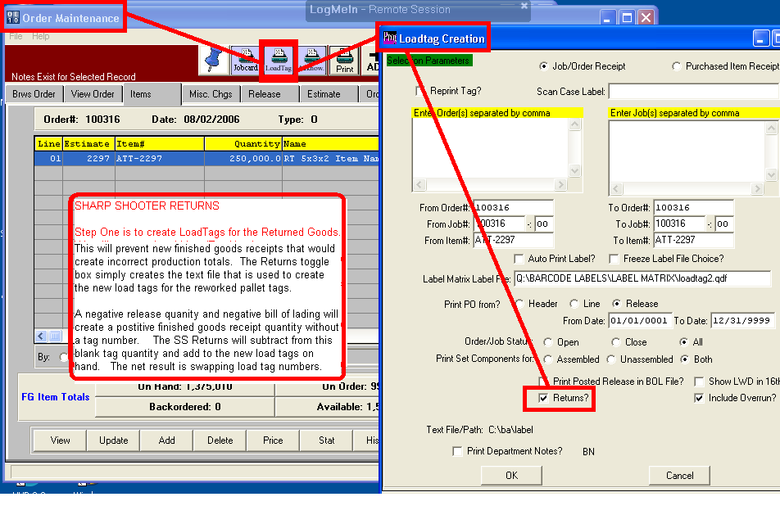
Step 7 POSTING RETURNS

This option is used when N-K-1 BolPost Logical Value = YES, which created a blank tag with a positive balance equal to the negative release quantity. Posting Sharp Shooter RETURNED GOODS will simultaneously increase the new Tag Quantity and decrease the Blank Tag created via the negative release. The F1 key will show only Load Tags that have not been received. This will show the load tags created but never received when creating the load tags with the Returns toggle box checked. RETURNS in sharp shooter finished goods provides for receiving the new load tags by reducing the finished goods bin location with a blank tag number. Therefore, the inventory created by the negative release will be reduced as each new load tag is scanned into the system via the Sharp Shooter Return Goods program.

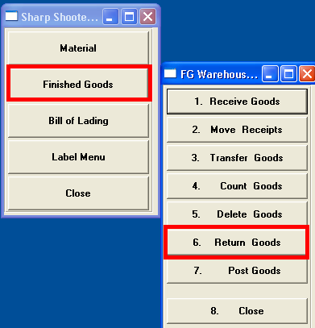

POST RETURNS which will also have a new toggle button called ZERO OUT RETURNS that will create a physical count for the balance not scanned during the rework process. Hence the new TOGGLE box called ZERO OUT RETURNS will create a physical count equal to 0 on hand for the blank tag number created via the negative release. This logic will be at the end of the RETURN POST logic, so that when the scanned returns are less than the bin quantity on hand for the blank tag number, a new physical count will automatically be created. This will only happen when the ZERO OUT RETURNS is checked.
For example, we ship 10 units at 1000 per pallet with tag numbered 1 to 10. Two units are returned by creating a negative release for 2000, which creates a bill of lading for -2 units at 1000 per unit with NO TAG Number. This creates a negative invoice, thus updating the inventory with 2000 on hand without a tag number. After reworking the returns we create tag number 11 with 1 unit of 1000 and tag number 12 with a pallet count of 600. The POST button of returns will reduce the blank tag number to 400 boxes. The new release will create a bill of lading for 1600 and invoice for 1600. The problem is that the remaining 400 boxes from the original negative release of 2000 are no good or trash, hence we need a physical count created for the blank tag number. By checking the ZERO OUT RETURNS toggle button, the finished goods for the blank tag number will be zero after the physical counts are posted.

